***Supplementary Material***

**Microplastics but not natural particles induce multigenerational effects in *Daphnia magna***

Christoph Schüra*, Sebastian Zippa, Tobias Thalaua, Martin Wagnerb

a Department of Aquatic Ecotoxicology, Faculty of Biological Sciences, Goethe University Frankfurt am Main, Max-von-Laue-Str. 13, 60438 Frankfurt am Main, Germany

b Department of Biology, Norwegian University of Science and Technology, 5 Høgskoleringen, 7491 Trondheim, Norway

*Address correspondence to Martin Wagner, martin.wagner@ntnu.no

**Material and particle characterization**

We confirmed the polymer type of the plastic material used in this study (Figure S7), its density (Table S1) and provide scanning electron microscopy images (Figure S1) and particle size distributions (Figure S6) of both particle types.

Fourier-transform infrared spectroscopy (FTIR) was performed on a PerkinElmer Spectrum Two instrument in ATR mode (4000–400 cm-1). The FTIR spectrum of the coffee cup lid (Figure S7) was compared to a spectral library using the siMPle software (Version 1.0.0., http://www.simple-plastics.eu) and matched “Polystyrene.67” with a score of 61.2 %. Thus, the coffee cup lids consisted of polystyrene.

We estimated the density of the polystyrene by punching out 20 circles from the flat area of two coffee cup lids. We determined their size (Figure S8, Table S1, Olympus SZX7, Olympus cellSens Standard 2.2) and weight (Table S1) and calculated the area and volume of the circles to derive the density which was 0.81 ± 0.06 g cm‑3. This is likely an underestimation since measuring the thickness of the material under the binocular produced some variability (± 7.2 % relative standard deviation (RSD)) which translates to a RSD of 7.8 % in the density. Puncturing the material did not produce perfect edges, which increased uncertainty regarding material diameter and thickness. Since according to the literature PS has a density of 0.96–1.05 g cm-3 (Lambert and Wagner 2018), we can assume that the particles will be more or less neutrally buoyant in the water column.

In the exposure vessels with the high MP concentration (2000 and 10000 particles mL-1) some particles floated on the surface shortly after application, while the majority remained buoyant in the water column. The suspensions of both particle types were shaken in medium for at least 48 h prior to application in the test. This markedly improved stability of the PS suspensions, whereas no change was visible for kaolin particles. The ratio of floating and suspended particles was not determined. As discussed in the main manuscript, kaolin sedimented rather quickly.

Table S5 provides theoretical sinking velocities for particles with different densities and sizes. The particle size distributions are available in Figure S6.

To investigate the particle shapes and surface characteristics of the PS MP and kaolin we recoded micrographs at 300× and 1500× magnification using a Hitachi S-4500 scanning electron microscope (Figure S1). While the particle types differ in size (kaolin particles are smaller than PS MP, their irregular shape and rough surface is similar.

Herrington et al (1992) provide information on the surface charge of kaolin.

Table S1: Determination of the density of the polystyrene coffee cup lids used to make microplastics. Flat areas from the center part of the lid were punch holed (n=20). These circles were then measured in diameter, thickness, and weight from which the surface area, volume and density were calculated.

|  |  |  |  |  |  |  |
| --- | --- | --- | --- | --- | --- | --- |
| Replicate | Measured diameter [mm] | Measured thickness [mm] | Measured weight [mg] | Calculated surface area [mm2] | Calculated volume [mm3] | Calculated density [g cm-3] |
| 1 | 5.37 | 0.230 | 7.21 | 22.67 | 5.22 | 0.72 |
| 2 | 5.39 | 0.234 | 7.19 | 22.83 | 5.35 | 0.74 |
| 3 | 5.39 | 0.221 | 7.30 | 22.80 | 5.03 | 0.69 |
| 4 | 5.37 | 0.258 | 7.50 | 22.67 | 5.84 | 0.78 |
| 5 | 5.52 | 0.241 | 7.03 | 23.93 | 5.77 | 0.82 |
| 6 | 5.38 | 0.264 | 7.12 | 22.70 | 6.00 | 0.84 |
| 7 | 5.47 | 0.245 | 7.46 | 23.52 | 5.75 | 0.77 |
| 8 | 5.50 | 0.246 | 7.12 | 23.74 | 5.84 | 0.82 |
| 9 | 5.34 | 0.256 | 7.22 | 22.39 | 5.73 | 0.79 |
| 10 | 5.35 | 0.273 | 7.31 | 22.48 | 6.14 | 0.84 |
| 11 | 5.34 | 0.264 | 7.07 | 22.42 | 5.92 | 0.84 |
| 12 | 5.32 | 0.249 | 7.31 | 22.24 | 5.53 | 0.76 |
| 13 | 5.31 | 0.280 | 7.05 | 22.18 | 6.20 | 0.88 |
| 14 | 5.33 | 0.281 | 7.44 | 22.33 | 6.28 | 0.84 |
| 15 | 5.41 | 0.267 | 7.19 | 22.98 | 6.14 | 0.85 |
| 16 | 5.34 | 0.234 | 6.99 | 22.39 | 5.24 | 0.75 |
| 17 | 5.34 | 0.279 | 7.22 | 22.42 | 6.26 | 0.87 |
| 18 | 5.36 | 0.284 | 7.16 | 22.58 | 6.40 | 0.89 |
| 19 | 5.32 | 0.256 | 7.07 | 22.24 | 5.69 | 0.80 |
| 20 | 5.30 | 0.280 | 6.38 | 22.08 | 6.18 | 0.97 |
| Mean | **5.37** | **0.257** | **7.17** | **22.68** | **5.83** | **0.81** |
| SD | **0.059** | **0.019** | **0.230** | **0.500** | **0.380** | **0.060** |
| RSD [%] | **1.1** | **7.3** | **3.1** | **2.2** | **6.6** | **7.8** |



**Figure S1: Scanning electron microscope images of the kaolin (A+B) and polystyrene (C+D) particles used in this study at 300× (A+C) and 1500× (C+D) magnification.**

**Reproduction at different food levels**

Since we aimed at conducting the multigenerational experiment using low-food conditions, we performed a Daphnia reproduction test (OECD 2012) with different food levels (0.01, 0.025, 0.05, 0.075, 0.1, and 0.2 mgC daphnid-1 day-1). Feeding with 0.1 and 0.2 mg C individual-1 d-1 are the conditions recommended in the OECD guideline 211 (OECD 2012). 0.05 mgC daphnid-1 d-1 was the lowest food level that still resulted in reproductive output that met the validity criteria of the OECD 211 guideline (60 neonates per surviving adult) and was, therefore, selected as the low food level to be used in the multigenerational experiment (Figure S2).

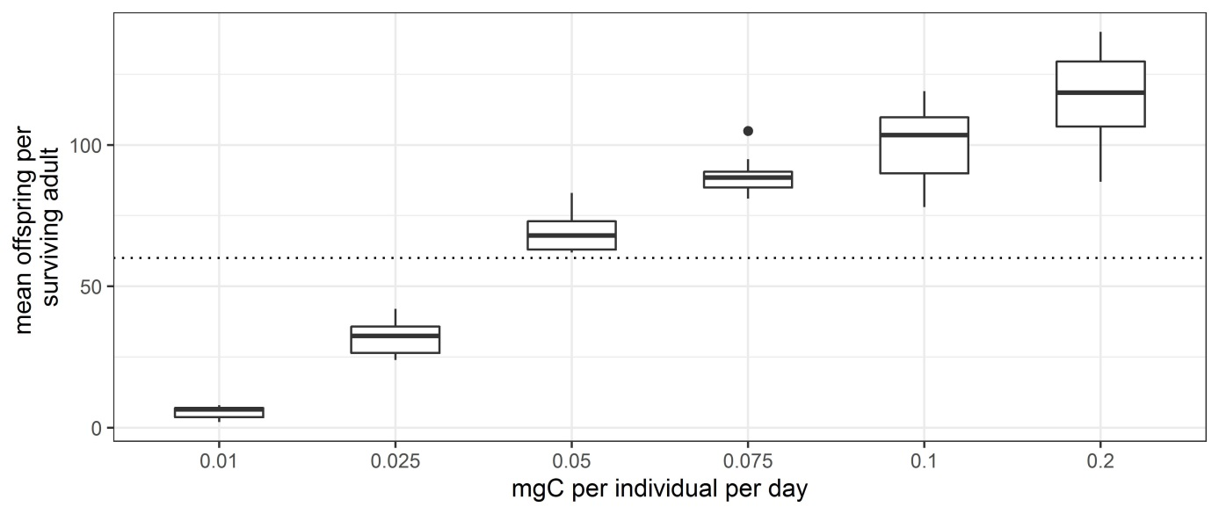

**Figure S2: Reproductive output of *D. magna* individuals during 21 d under different feeding regimens**. Animals were held individually and fed 0.01, 0.025, 0.05, 0.075, 0.1, or 0.2 mg carbon individual-1 d-1. The two levels of 0.1 and 0.2 mg C individual-1 d-1 are the feeding conditions proposed in the OECD guideline 211 (OECD 2012). The dotted line indicates the OECD 211 validity criterion of minimum produced offspring per surviving adult animal over 21 d.

Table S2: Nominal and measured particle concentrations. For each treatment, at least three vessels were prepared identical to the ones used to expose daphnids but did not contain algae and animal.

|  |  |  |  |
| --- | --- | --- | --- |
| Treatment | Nominal concentration (particles mL-1) | Mean measured concentration ± SD (particles mL-1) | N (replicates with 3 technical replicates each) |
| PS400 | 400 | 787 ± 53.7 | 3 |
| PS2000 | 2000 | 2005 ± 262.5 | 3 |
| PS10000 | 10000 | 12234 ± 2214 | 4 |
| Kaolin400 | 400 | 1776 ± 829.9 | 4 |
| Kaolin2000 | 2000 | 3928 ± 309.2 | 4 |
| Kaolin10000 | 10000 | 10195 ± 1793.8 | 3 |

**Table S3: Results of the acute toxicity tests with potassium dichromate conducted with the 4th brood of each treatment per generation**, given as 50 % lethal concentration (LC50) values with the range of the 95 % confidence interval. n.a. = not analyzed

| Treatment | Generation | N (animals/replicate) | LC50 | 95 % Confidence Interval |
| --- | --- | --- | --- | --- |
| HFC | 0 | 4 (5) | 0.844 | 0.812–0.878 |
| 1 | 4 (5) | 0.882 | 0.867–0.898 |
| 2 | 4 (5) | 0.885 | 0.838–0.935 |
| 3 | 4 (5) | 1.032 | 0.994–1.070 |
| LFC | 0 | 4 (5) | 0.875 | 0.842–0.911 |
| 1 | 4 (5) | 0.659 | (very wide) |
| 2 | 4 (5) | 0.623 | 0.570–0.680 |
| 3 | 3 (5) | 0.797 | 0.777–0.817 |
| PS400 | 0 | 4 (5) | 0.836 | 0.786–0.888 |
| 1 | 3 (5) | 0.731 | 0.679–0.785 |
| 2 | 3 (5) | 0.758 | (very wide) |
| 3 | 3 (5) | 0.918 | 0.892–0.944 |
| PS2000 | 0 | 4 (5) | 0.988 | 0.942–1.037 |
|  | 1–3 | n.a. because of low reproduction | | |
| PS10000 | 0 | n.a. because of low reproduction | | |
|  | 1–3 | n.a. because of extinction | | |
| Kaolin400 | 0 | 4 (5) | 1.043 | 0.991–1.098 |
| 1 | 4 (5) | 0.633 | 0.575–0.698 |
| 2 | 4 (5) | 0.755 | 0.691–0.824 |
| 3 | 3 (5) | 0.769 | 0.747–0.791 |
| Kaolin2000 | 0 | 4 (5) | 0.860 | 0.765–0.968 |
| 1 | 4 (5) | 0.611 | 0.556–0.672 |
| 2 | 4 (5) | 0.801 | 0.773–0.830 |
| 3 | 4 (5) | 1.472 | 1.396–1.553 |
| Kaolin10000 | 0 | 4 (5) | 0.923 | 0.880–0.967 |
|  | 1–3 | n.a. | | |

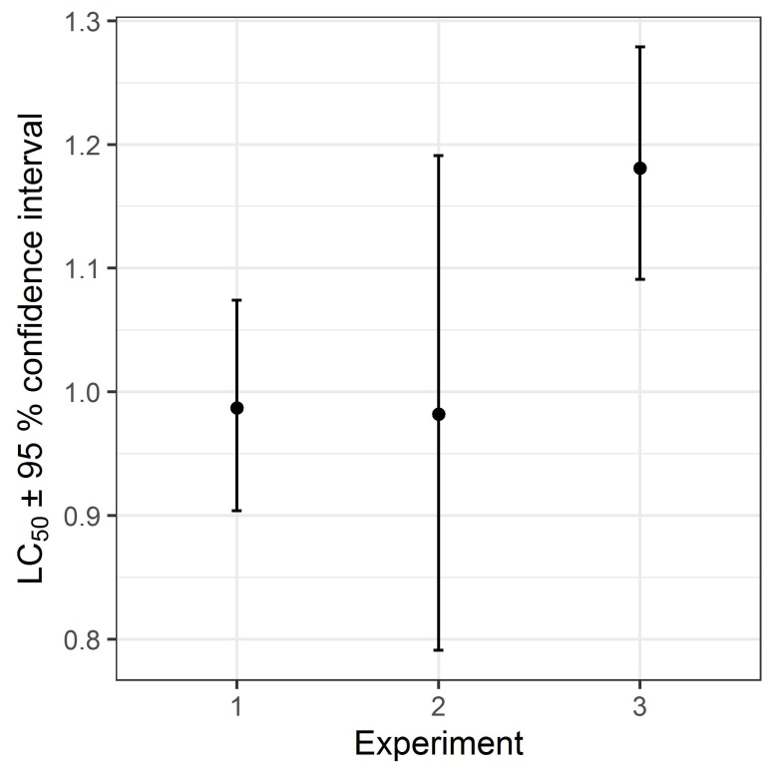

**Figure S3: Lethal concentrations for 50 % (LC50) of neonate *D. magna* in three independent acute toxicity tests with potassium dichromate**, performed with neonates from a laboratory culture maintained at high food levels (0.15 mg carbon individual-1 d-1).

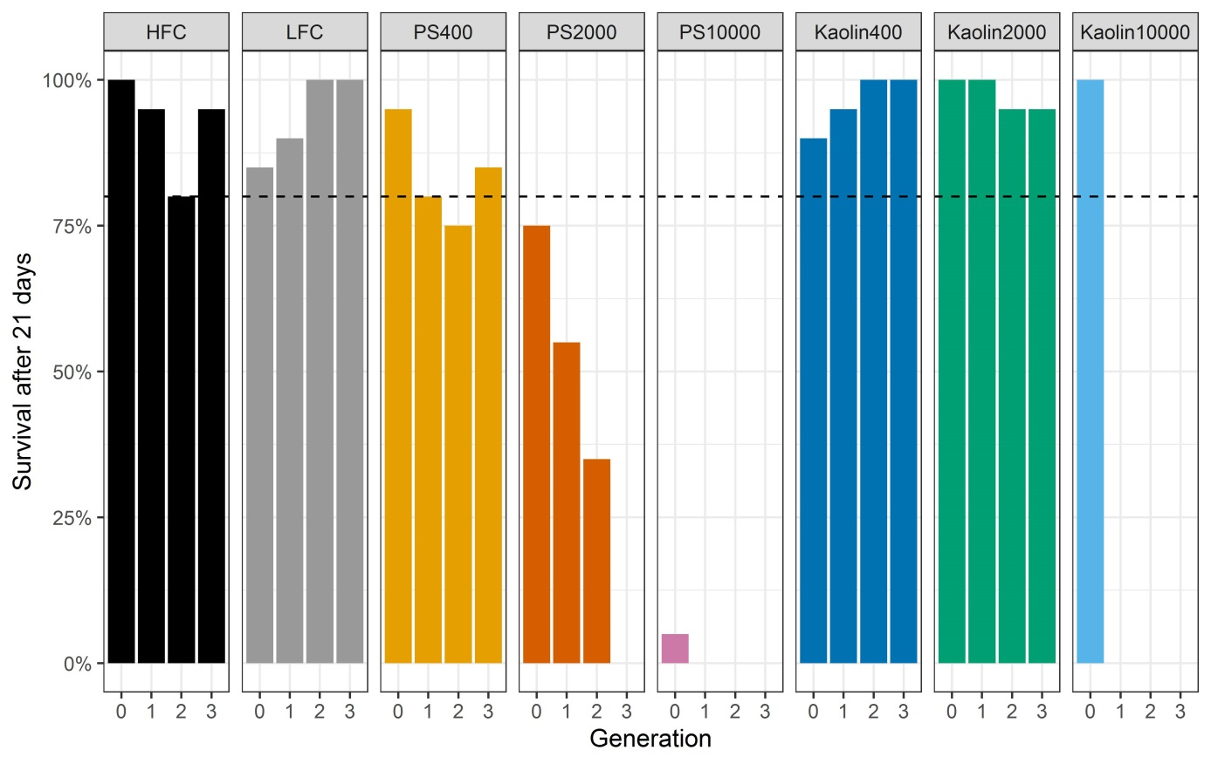

Figure S4: Survival of *Daphnia magna* at the end of each generation and exposure to high food levels (HFC), low food levels (LFC) and three concentrations (400, 2000, and 10000 particles mL-1) each of polystyrene (PS) microplastics and kaolin. The dotted line indicates the OECD 211 validity criterion (80 % survival in the controls).

Table S4: Daphnid survival at the end of each generation, mean first day of reproduction, mean offspring per surviving adult, and median size per surviving adult.

| Treatment | Generation | Survival after 21 d [%] | Mean day of  first reproduction ±  SD | Mean offspring per surviving adult ± SD | Median size per surviving adult ± SD [µm] |
| --- | --- | --- | --- | --- | --- |
| HFC | 0 | 100 | 11.33 ± 1.53 | 78.2 ± 29.6 | 4592 ± 521 |
| HFC | 1 | 95 | 11.50 ± 1.29 | 52.5 ± 19.0 | 4391 ± 183 |
| HFC | 2 | 80 | 11.50 ± 0.71 | 76.4 ± 25.1 | 4454 ± 168 |
| HFC | 3 | 95 | 14.80 ± 1.92 | 82.9 ± 24.1 | 4039 ± 288 |
| LFC | 0 | 85 | 11.75 ± 1.71 | 49.5 ± 15.8 | 3989 ± 410 |
| LFC | 1 | 90 | 13.00 ± 2.61 | 21.1 ± 14.6 | 3812 ± 634 |
| LFC | 2 | 100 | 11.50 ± 0.71 | 39.6 ± 13.1 | 3890 ± 109 |
| LFC | 3 | 100 | 12.33 ± 1.53 | 44.0 ± 8.13 | 3728 ± 93 |
| PS400 | 0 | 95 | 12.00 ± 2.65 | 52.8 ± 10.7 | 3973 ± 195 |
| PS400 | 1 | 80 | 11.50 ± 0.71 | 25.8 ± 10.3 | 3566 ± 545 |
| PS400 | 2 | 75 | 12.00 ± 1.00 | 28.8 ± 15.2 | 3554 ± 385 |
| PS400 | 3 | 85 | 13.00 ± 1.58 | 33.0 ± 11.8 | 3438 ± 525 |
| PS2000 | 0 | 75 | 10.50 ± 0.71 | 45.3 ± 18.8 | 3814 ± 472 |
| PS2000 | 1 | 55 | 14.83 ± 3.76 | 16.4 ± 7.42 | 3169 ± 254 |
| PS2000 | 2 | 35 | 13.50 ± 1.29 | 16.4 ± 4.86 | n.a.a |
| PS2000 | 3 | 0 | - | - | - |
| PS10000 | 0 | 5 | - | - | 2545 |
| Kaolin400 | 0 | 90 | 12.00 ± 2.65 | 50.7 ± 13.2 | 4033 ± 146 |
| Kaolin400 | 1 | 95 | 13.40 ± 2.30 | 28.6 ± 13.1 | 3802 ± 348 |
| Kaolin400 | 2 | 100 | 13.00 ± 2.00 | 43.0 ± 15.6 | 3867 ± 331 |
| Kaolin400 | 3 | 100 | 12.50 ± 2.12 | 48.1 ± 14.5 | 3858 ± 212 |
| Kaolin2000 | 0 | 100 | 13.50 ± 4.04 | 52.0 ± 19.0 | 4120 ± 493 |
| Kaolin2000 | 1 | 100 | 12.00 ± 1.58 | 33.4 ± 14.3 | 3814 ± 168 |
| Kaolin2000 | 2 | 95 | 11.00 ± 0.00 | 44.2 ± 11.9 | 3878 ± 123 |
| Kaolin2000 | 3 | 95 | 12.67 ± 2.08 | 48.6 ± 11.9 | 3781 ± 225 |
| Kaolin10000 | 0 | 100 | 12.00 ± 2.16 | 53.7 ± 16.8 | 4060 ± 437 |

a not analyzed because the animals were accidently discarded before size measurements

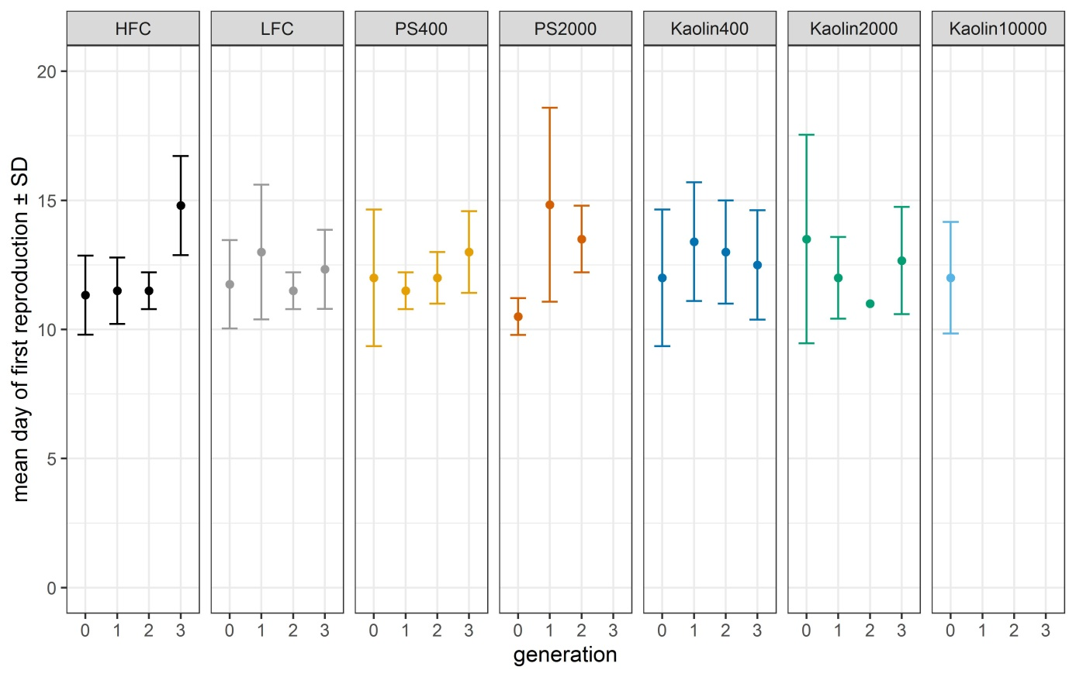

Figure S5: Mean day of first reproduction of *Daphnia magna* after 21 days exposure to high food levels (HFC), low food levels (LFC) and three concentrations (400, 2000, and 10000 particles mL-1) each of polystyrene (PS) microplastics and kaolin. The Kaolin10000 treatment group was discontinued after the extinction of the PS10000 treatment group in the first generation (F0).

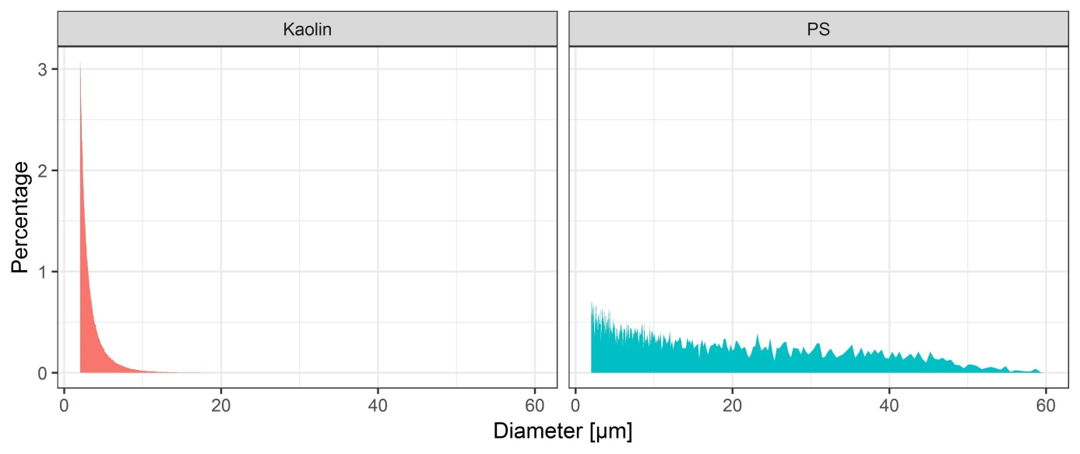

**Figure S6: Particle size distributions for kaolin and PS particles.** The size distribution was derived from 1 g L-1 stock suspensions in M4 medium using a Beckman Coulter Multisizer 3.

Table S5: Theoretical sinking velocities for hypothetical spherical particles made of polystyrene or kaolin.

|  |  |  |  |
| --- | --- | --- | --- |
| Material type | Assumed density [g cm-3] | Hypothetical particle diameter [µm] | Calculated sinking velocity [cm h-1] |
| Kaolin | 2.6 | 1 | 0.33 |
|  |  | 10 | 32.9 |
| Polystyrene | 0.95/1.05 | 1 | -0.0098/0.0098 |
|  |  | 10 | -0.9826/0.9826 |

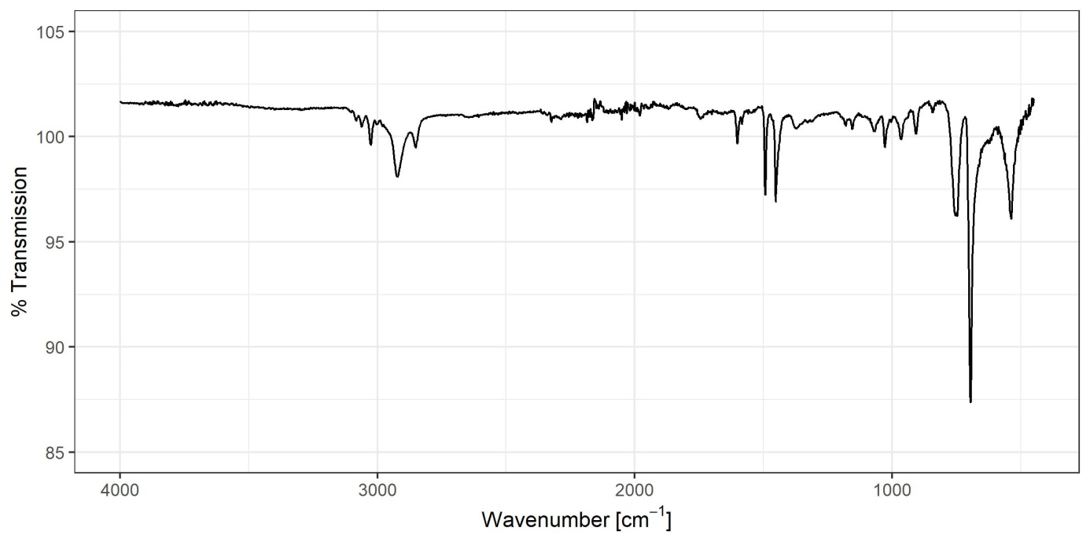

**Figure S7: Fourier-transform infrared spectrum of the coffee cup lid material used to produce the irregular microplastics particles used throughout the study.** The spectrum confirms that the plastic is polystyrene.

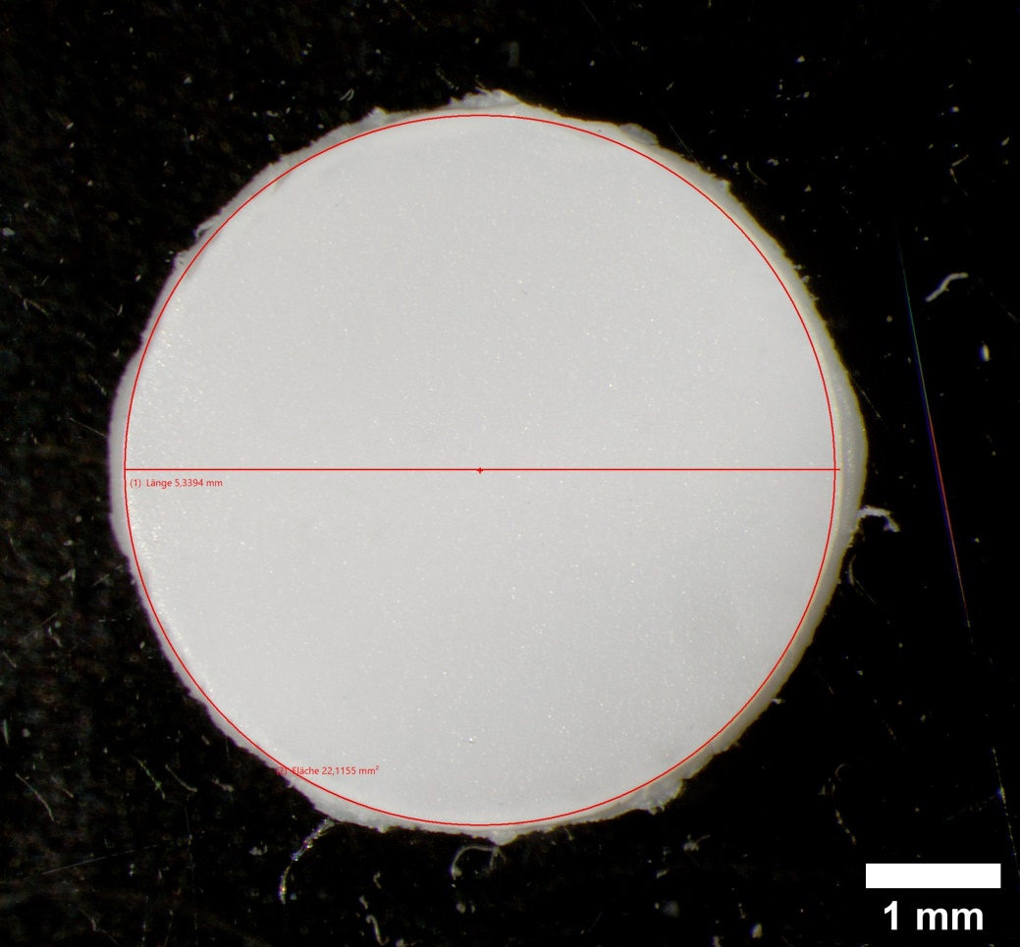

Figure S8: Example of a plastic circle from a coffee cup lid (replicate 9) used to determine the density. Flat areas from the center part of the lid were punch holed (n=20). The circular pieces were then measured in diameter, thickness, and weight from which the surface area, volume and density was calculated.

References

Herrington, T.M., A.Q. Clarke, and J.C. Watts. 1992. “The Surface Charge of Kaolin.” *Colloids and Surfaces* 68 (3): 161–69. https://doi.org/10.1016/0166-6622(92)80200-L.

Lambert, Scott, and Martin Wagner. 2018. “Microplastics Are Contaminants of Emerging Concern in Freshwater Environments: An Overview.” In *Freshwater Microplastics*, 1–23. The Handbook of Environmental Chemistry. Springer, Cham. https://doi.org/10.1007/978-3-319-61615-5_1.

OECD. 2012. *Test No. 211:* Daphnia Magna *Reproduction Test*. Paris: Organisation for Economic Co-operation and Development. http://www.oecd-ilibrary.org/content/book/9789264185203-en.